**Flow Visualization of a Symmetric Airfoil and Pressure Distribution over a Multi-Surfaced Cylinder**

Charles Keer

AE 315

*Department of Aerospace Engineering*

*Embry-Riddle Aeronautical University, Daytona Beach, FL,32114-3900*

**Introduction**

Flow visualization in a wind tunnel is a useful tool for observing how fluids will interact with an object. For the first experiment conducted, a symmetrical airfoil was placed inside of a wind tunnel where smoke was injected. This allowed for the flow fields to be visualized over a variety of angles of attacks. This is useful for determining stall conditions and observing the turbulent wake of the airfoil. Additionally, wind tunnels can be used for measuring and calculating a variety of variety of values. In the second experiment conducted, a smooth and rough cylinder were placed in a wind tunnel with a pressure port located on the surface of the cylinders. The cylinders were then rotated incrementally to measure the pressure distribution over the surface. This experiment is useful because it provides a method of experimentally calculating pressure coefficients of an object.

**Results and Discussion**

The flow visualization experiment was performed in an open-circuit wind tunnel on a symmetrical airfoil measuring approximately 40 centimeters in length. Two visualization experiments were performed, one at 3 meters per second, and one at 6 meters per second. The velocity in the wind tunnel was measured by a pitot-static tube located upstream of the airfoil. The pitot-static tube interfaced with a DAQ that displayed the dynamic pressure in inches of water. Smoke was also introduced upstream of the airfoil. The velocity of the wind tunnel was increased until the dynamic pressure on the DAQ reached the calculated dynamic pressure for that day’s conditions.

**Figure 1.** Schematic of the flow visualization over an airfoil (not to scale).

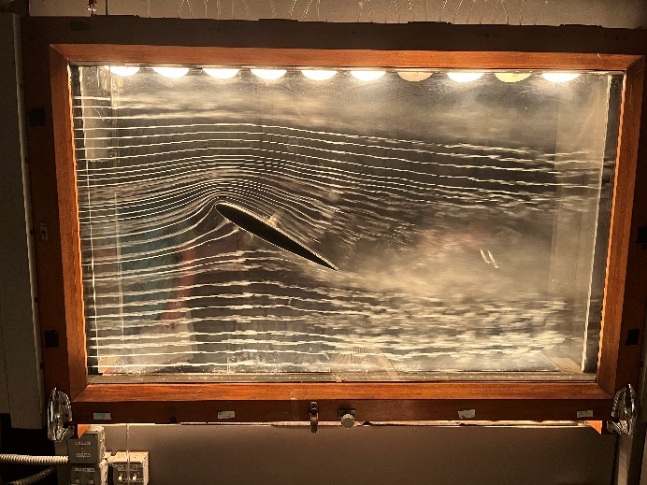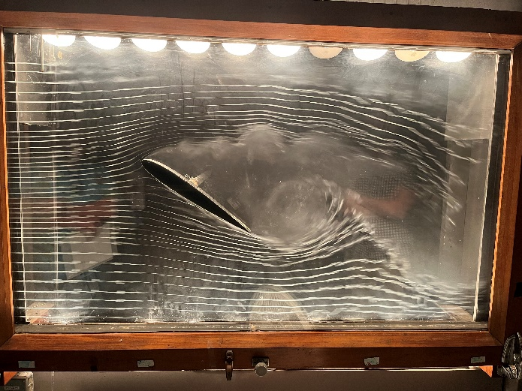The airfoil was set initially to a zero angle of attack. This was verified by one of the injected streamlines contacting the leading edge of the airfoil. Under these conditions, all the visual streamlines were attached and laminar, fulfilling the requirements for potential flow. The airfoil angle of attack was then slowly increased until the flow separated and entered a full stall condition (Figure 3). After full stall was reached, a vacuum pump was turned on, which added a lower pressure region on the top of the airfoil. This pulled the separated boundary layer back closer to the airfoil surface, effectively increasing the angle of attack where the airfoil would stall. This is a type of active flow control. An example of passive flow control would be notches or small raised areas in the airfoil surface (Sorensen, Zahle, et al. 2014). In both stall conditions, the stagnation point can be identified on the bottom half of the airfoil, significantly lower than the leading edge. This procedure was repeated for both the 3 and 6 meter per second experiment.

**Figure 2.** Airfoil at full stall. **Figure 3.** Airfoil at full stall AOA with vacuum.

Viewing Figures 2 and 3, the wake size difference can easily be seen. At full stall conditions, the flow separates at the leading edge of the airfoil, leaving the entire top surface in turbulent flow and leaving a large wake. Conversely, the vacuum forces the flow to stay attached for much longer along the surface, decreasing the size of the wake significantly. In both cases, the wake is not considered a part of potential flow due to the turbulence. With the vacuum turned on in Figure 3, there is more circulation around the airfoil, increasing the lift, according to the Kutta-Joukowski theorem.

The cylinder pressure distribution experiment was performed in a blower-style wind tunnel with cylinders measuring approximately 6 centimeters in diameter. One cylinder was covered in a rough sandpaper while the other was left smooth. In each cylinder, a small pressure port was located along the radius. This pressure port was connected to a computerized DAQ along with a pitot-static tube. Each cylinder followed the same procedure. Using the dynamic pressure and the equation for the coefficient of pressure, Eq. 1, the 0-degree position was found. This is where Cp equaled 1. During the experiment, the cylinder was rotated so the pressure port would be angled relative to the incoming flow. This was done incrementally from 0 to 180 degrees in steps of 10 degrees. Using a MATLAB code, 1,500 data points were taken at each angle and then averaged.

$C_{p}=\frac{(p-p_{∞})}{q_{∞}}$ (1)

The results of the experiment were plotted against the theoretical coefficient of pressure for a cylinder defined by:

(2)

Where theta is the angle of the static port relative to the incoming flow. Comparing the theoretical pressure distribution to the experimental shows a stark contrast. This is due to flow separation not being considered in potential flow.

**Figure 4.** Schematic of cylinder pressure distribution experiment.

It should be noted that there is a dip in the values of all experimental data before it has a horizontal asymptote. This dip is the region of lowest pressure and occurs just before the flow separates from the cylinder. After the flow has separated, the pressure in the turbulent region will remain constant, resulting in the horizontal part of the data. It should also be noted that the rough cylinders for both experiments took longer for the flow to detach. This is related to the turbulent

**Figure 6.** Pressure distribution for 10m/s. Red is smooth cylinder, green is rough cylinder, and yellow is theoretical.

**Figure 5.** Pressure distribution for 15m/s. Red is smooth cylinder, green is rough cylinder, and yellow is theoretical.

boundary layer that the rough surface creates. A dimpled golf ball would be a suitable example of this. A golf ball with dimples will fly much further than a smooth one due to the flow staying attached longer.

**Conclusion**

Flow visualization is a useful tool and has many applications for experimental aerodynamics. In the flow visualization experiment, an airfoil was shown in different stall conditions and angles of attack. This helped illustrate the relationship between the velocity potential and experimental data. In the cylinder experiment, the pressure distribution of a cylinder was examined with different surface textures and under different velocities. It was found that the flow separated much later a cylinder with a rough surface as compared to a cylinder with a smooth surface due to the more turbulent boundary layer.

**References**

Sørensen, N. N., Zahle, F., Bak, C., & Vronsky, T. (2014). Prediction of the effect of vortex generators on airfoil performance. *Journal of Physics: Conference Series*, *524*, 012019. https://doi.org/10.1088/1742-6596/524/1/012019